Abbie Conant and William Osborne
Trombone and Performance Art

Music for the End of Time
(For trombone, video and computer generated quadraphonic
Sound based on the Book of Revelation.)

Cybeline
(A music theater work for trombonist/performance-artist,
video and quadraphonic sound.)

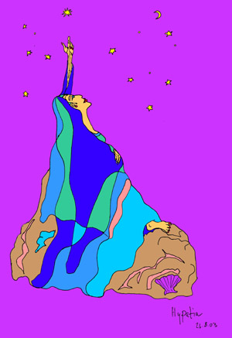 |  | 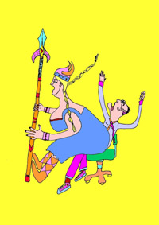
 | 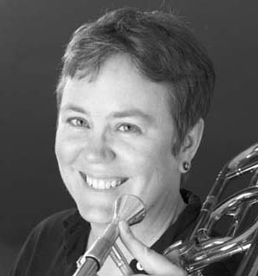
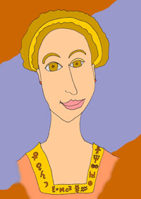 |  | 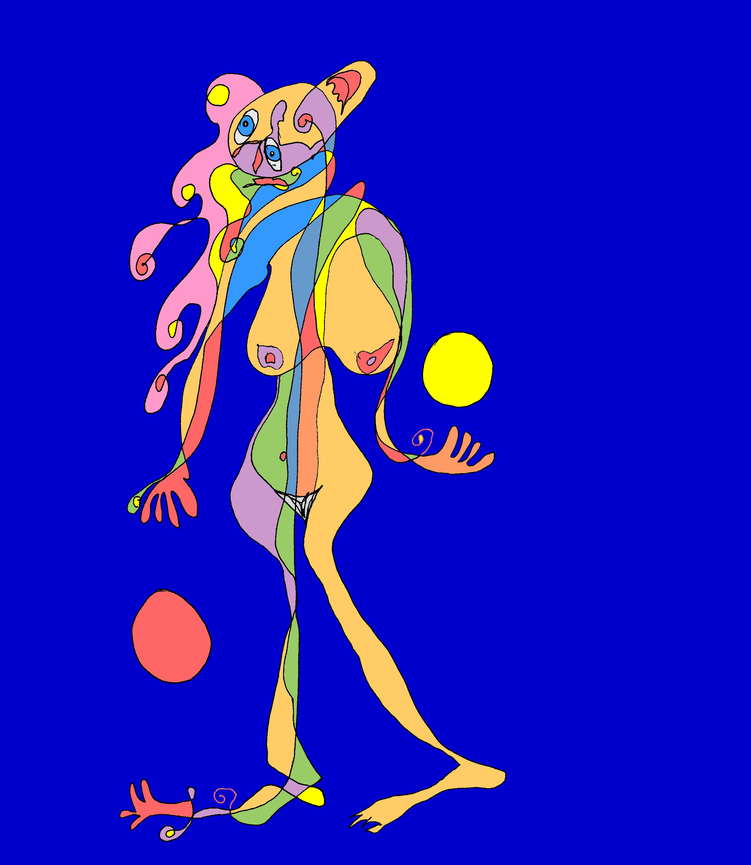
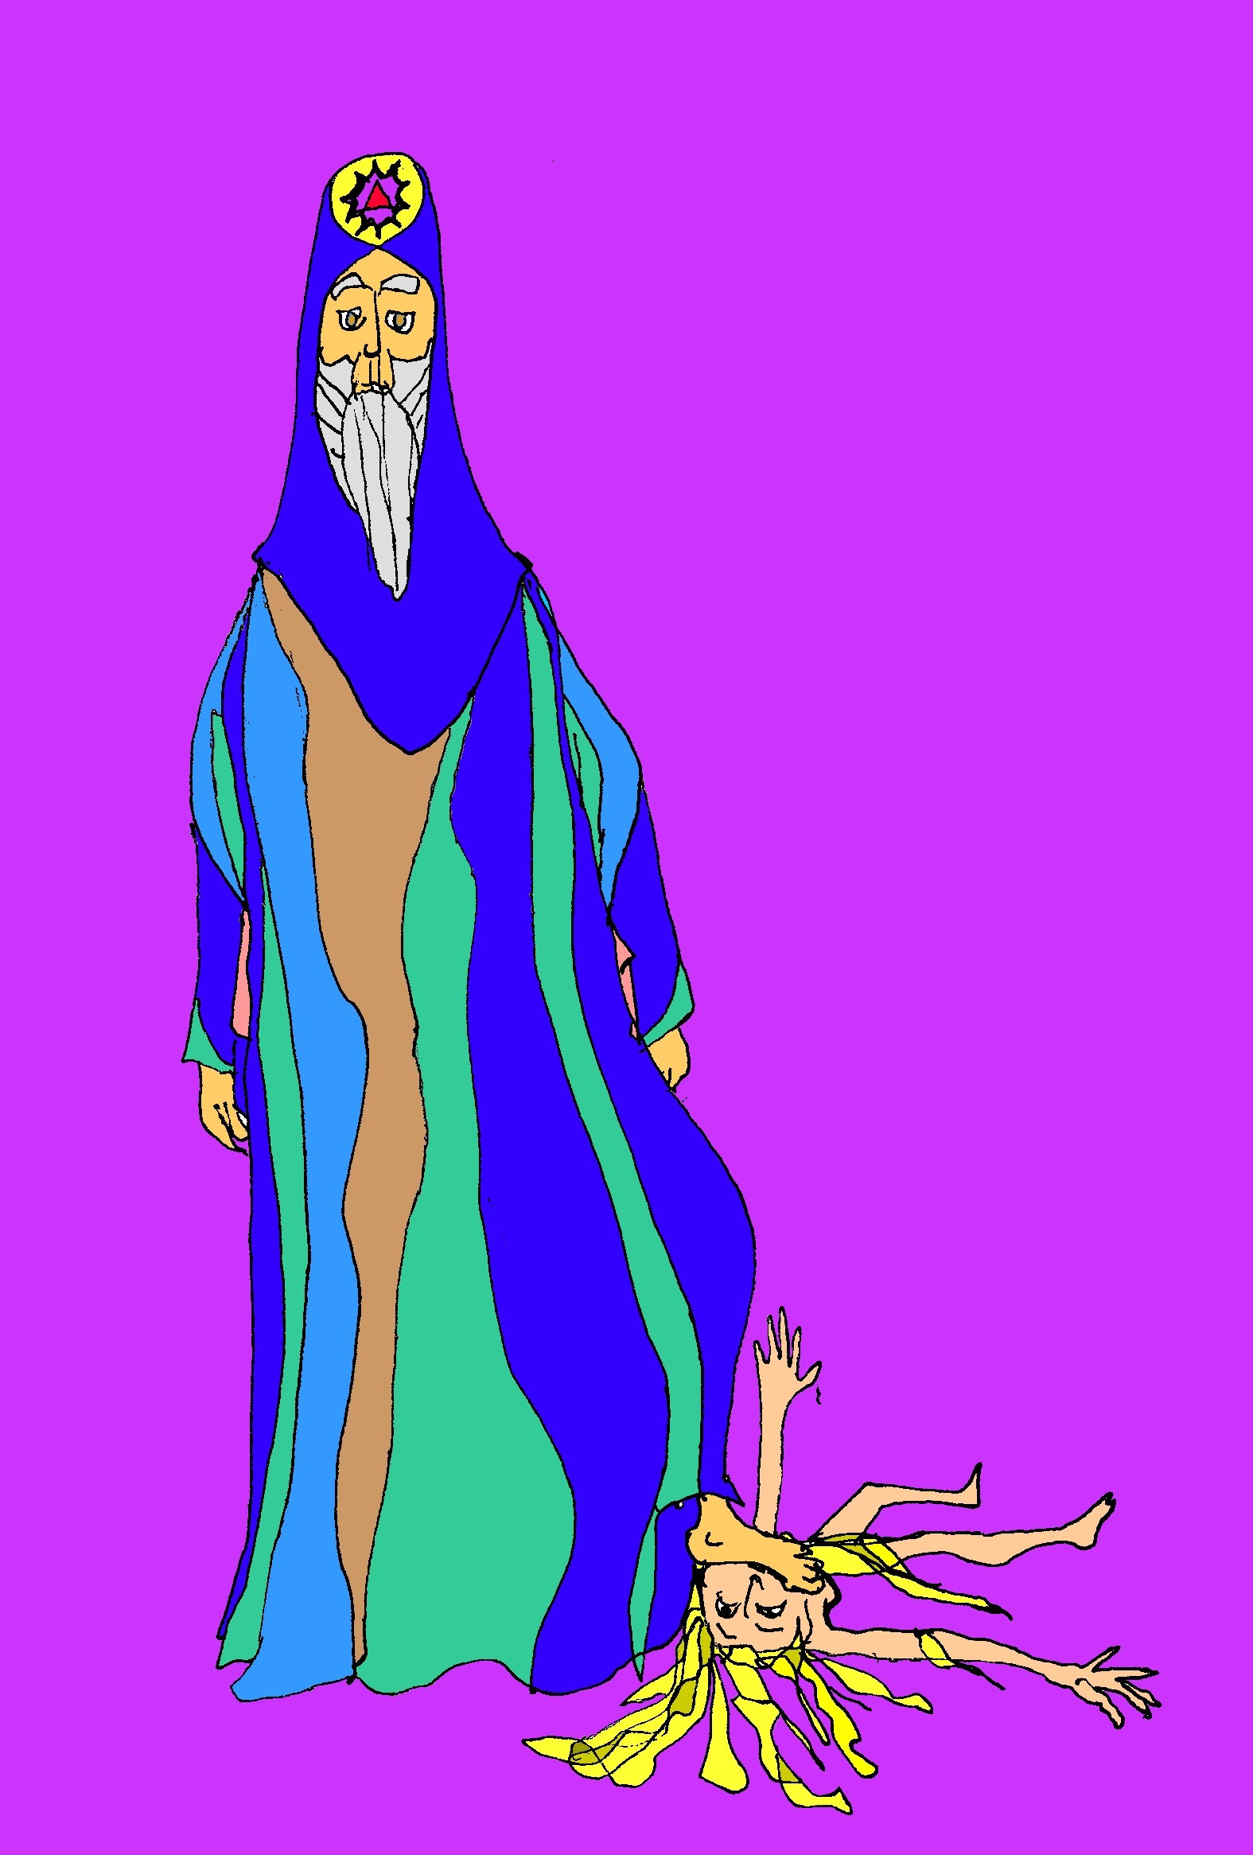 |  | 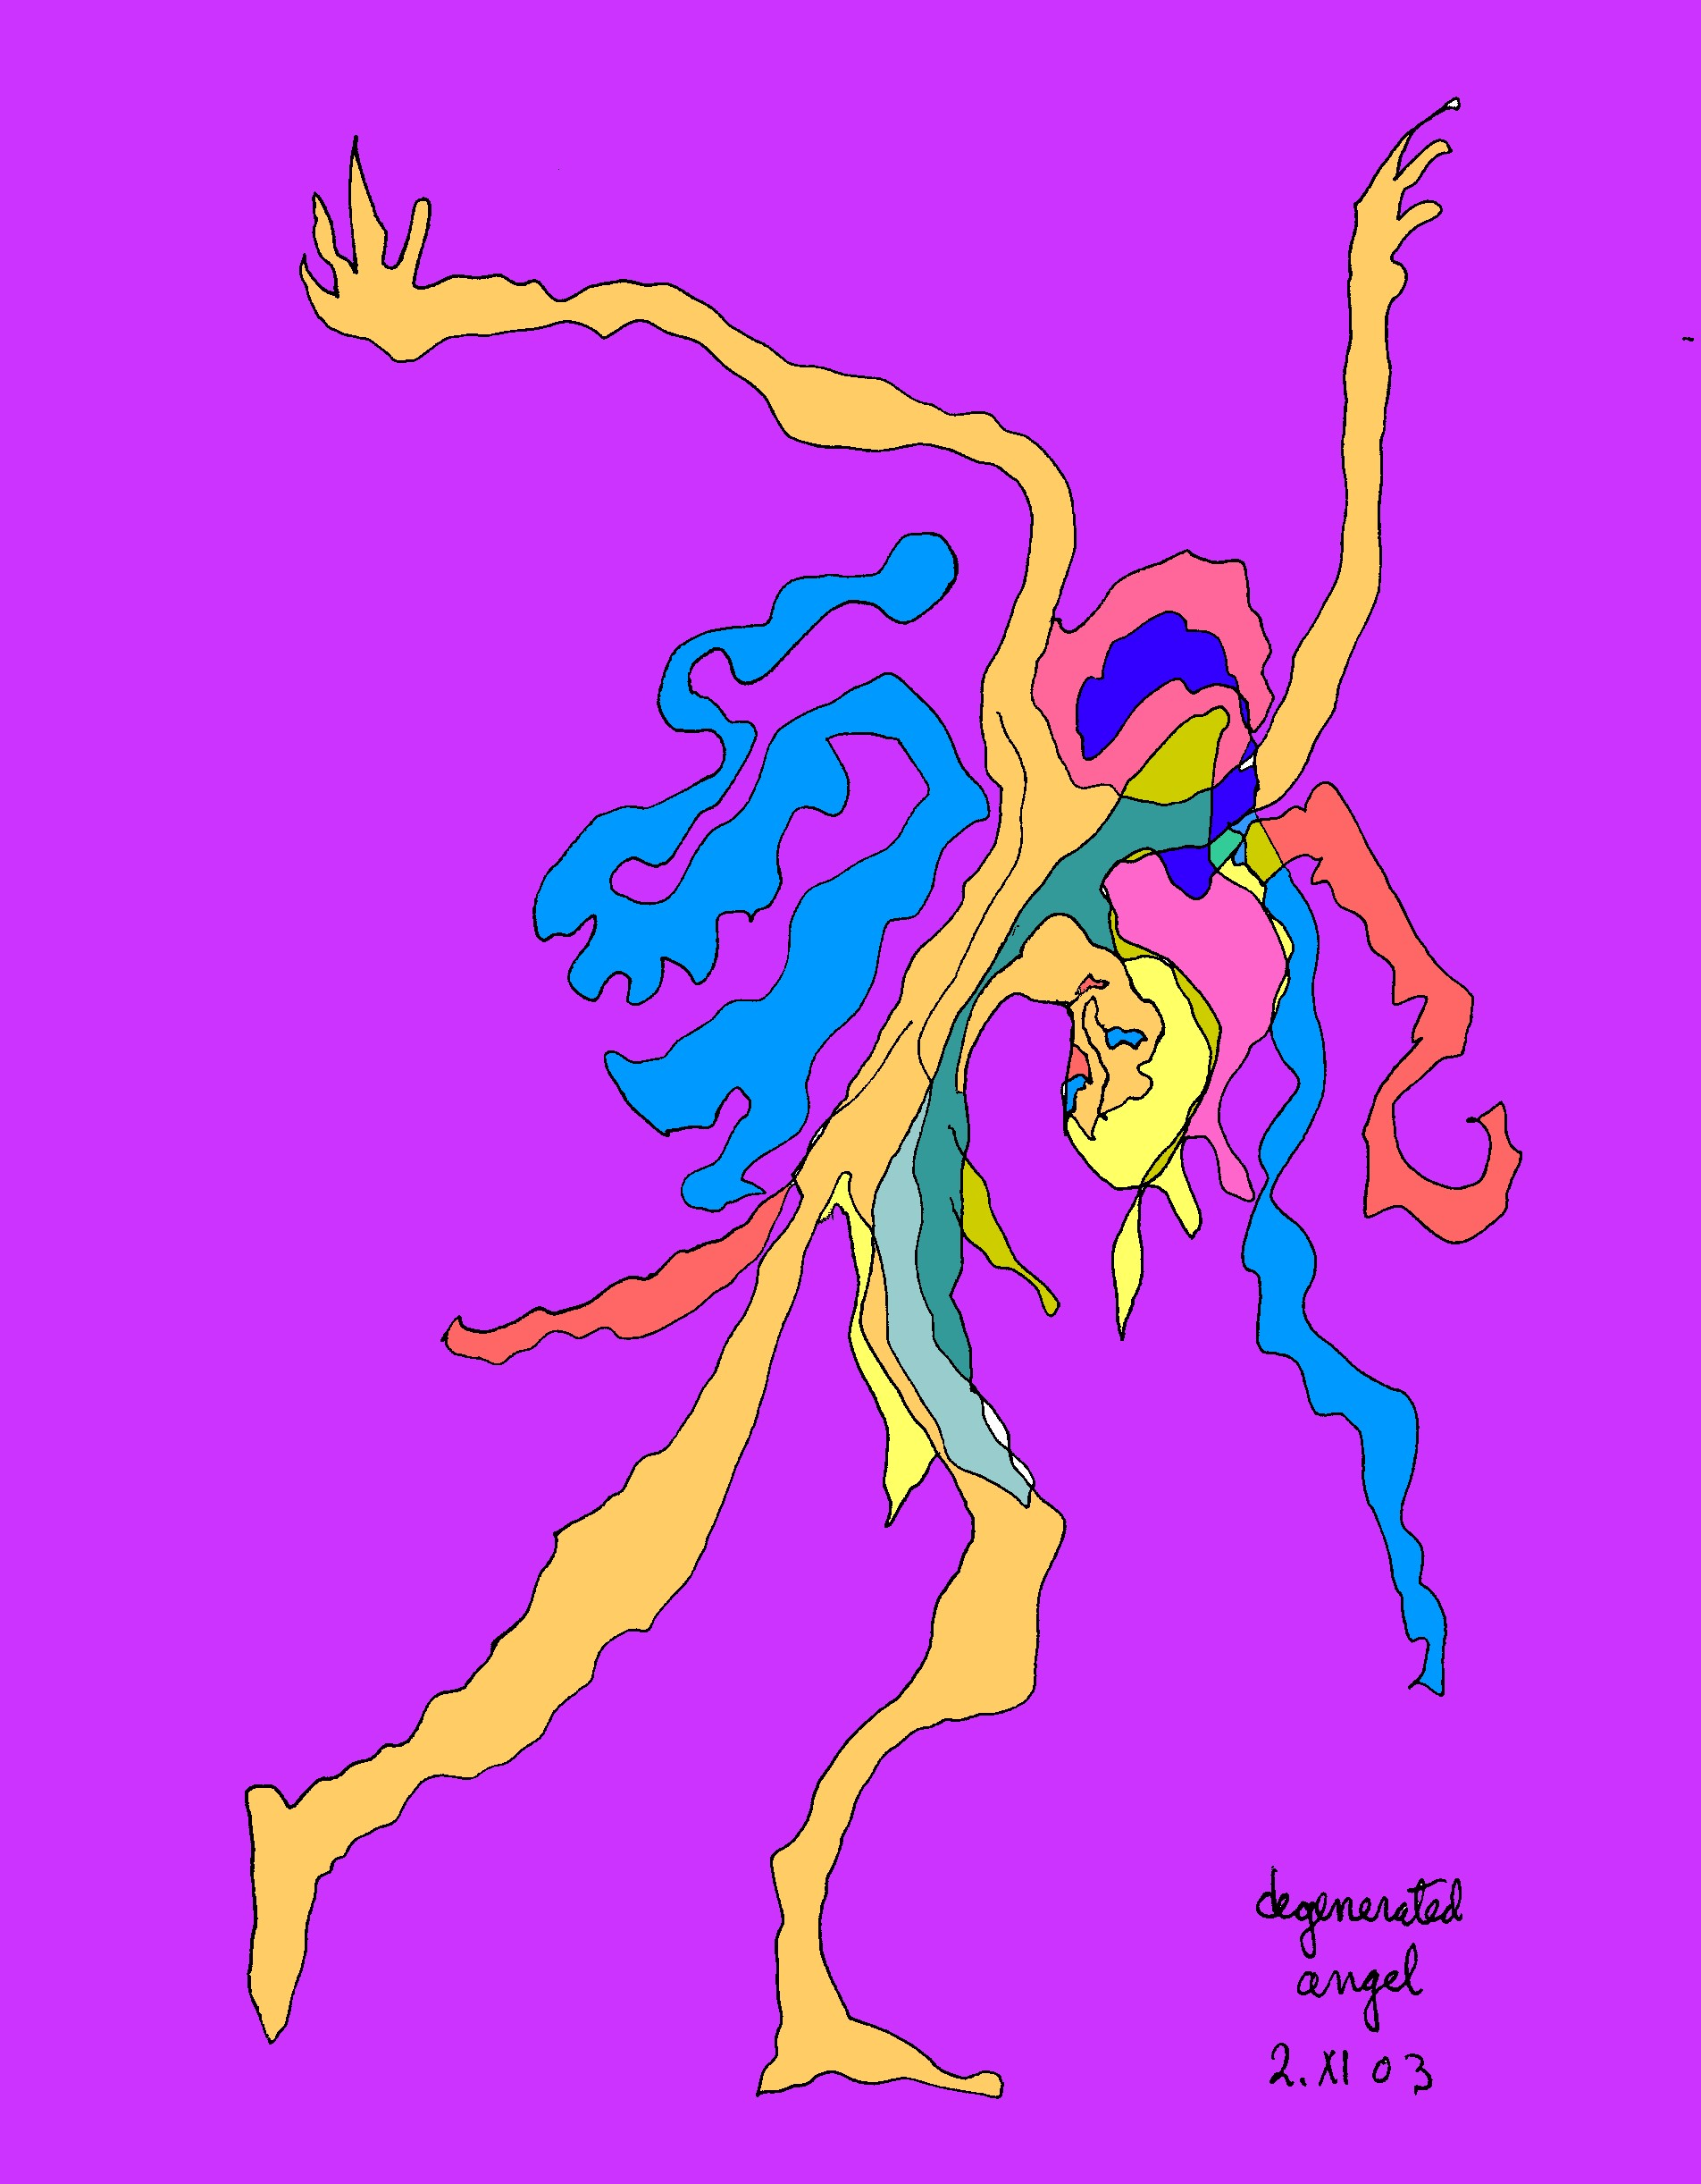
 | 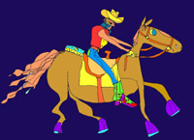
(Cartoons by Abbie Conant from the video of Cybeline.)

Your info here!!!!!

